2013 – Sem 2
Problem 6: Time Complexity of Divide-and-Conquer Algorithm (5 Points)
Professor Linear and Professor Zeki are having an argument over the time complexity of two algorithms for summing the elements of an integer array. Here is Professor Zeki's divide-and-conquer algorithm:
int Sum (int A[], int low, int high)
int mid;
begin
if (high low)
begin
mid (low high) / 2;
return Sum (A, low, mid) + Sum (A, mid+1, high);
end
else
return A[low];
end;
Professor Zeki claims that his divide-and-conquer algorithm has worst-case time complexity O(log n) and will therefore outperform Professor Linear's iterative O(n) algorithm which simples runs through all the elements of the array while keeping track of their total. Do you agree or disagree with Professor Zeki? Justify your answer.
I disagree with Professor Zeki's claim that his divide-and-conquer algorithm has a worst-case time complexity of O(log⁡n)O(\log n)O(logn). In fact, Professor Zeki’s algorithm has a time complexity of O(n)O(n)O(n), not O(log⁡n)O(\log n)O(logn).
Here’s why:
Breakdown of Professor Zeki's Algorithm:
- The algorithm divides the array into two halves recursively.
- It keeps splitting the array until it reaches subarrays of size 1, which requires n−1n-1n−1 recursive calls in total (where nnn is the size of the array).
- At each level of recursion, the algorithm performs a constant number of operations to combine the results of the two halves (i.e., a simple addition of two sums).
To analyze the time complexity, we can use a recurrence relation. Let T(n)T(n)T(n) represent the time complexity of summing an array of size nnn. The recurrence for this algorithm is:
T(n)=2T(n2)+O(1)T(n) = 2T\left(\frac{n}{2}\right) + O(1)T(n)=2T(2n​)+O(1)
This recurrence describes the fact that the algorithm breaks the array into two subarrays of size n/2n/2n/2 and adds a constant amount of work (the sum of the two halves).
This is a classic divide-and-conquer recurrence, and its solution can be found using the Master Theorem. The recurrence matches the form:
T(n)=aT(nb)+O(nd)T(n) = aT\left(\frac{n}{b}\right) + O(n^d)T(n)=aT(bn​)+O(nd)
where a=2a = 2a=2, b=2b = 2b=2, and d=0d = 0d=0 (since the combining step is constant work, O(1)O(1)O(1)). Applying the Master Theorem:
- Here, a=bda = b^da=bd because 2=202 = 2^02=20.
- According to the Master Theorem, if a=bda = b^da=bd, the time complexity is O(ndlog⁡n)O(n^d \log n)O(ndlogn).
Thus, the time complexity is:
T(n)=O(n0log⁡n)=O(log⁡n)T(n) = O(n^0 \log n) = O(\log n)T(n)=O(n0logn)=O(logn)
However, this is only the cost of the number of levels of recursion. Each level of recursion is making nnn calls, so the total time complexity is O(n)O(n)O(n).
Conclusion:
Professor Zeki's divide-and-conquer algorithm actually has a time complexity of O(n)O(n)O(n), the same as Professor Linear's iterative algorithm. Both algorithms take linear time in the worst case to sum an array of size nnn. Therefore, Professor Zeki is incorrect in claiming his algorithm outperforms Professor Linear's in terms of time complexity.

2014 – sem 1
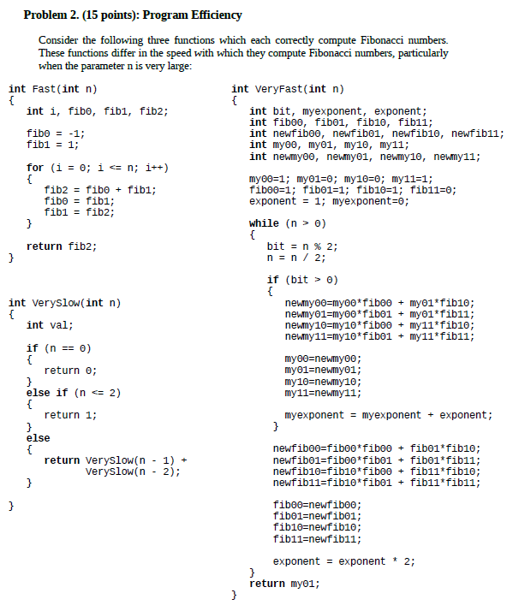

(a) Why is the Veryslow() function much slower than Fast() for large values of n?
The Veryslow() function computes Fibonacci numbers using recursion. It breaks down the Fibonacci calculation as:
return veryslow(n - 1) + veryslow(n - 2);
This approach recalculates Fibonacci values multiple times. For example, to compute veryslow(n), it will recursively compute veryslow(n-1) and veryslow(n-2), but when computing veryslow(n-1), it will again compute veryslow(n-2) and veryslow(n-3). This leads to overlapping subproblems, where many Fibonacci numbers are computed multiple times.
- Time complexity of Veryslow(): The recurrence relation for the function is:
T(n)=T(n−1)+T(n−2)+O(1)T(n) = T(n-1) + T(n-2) + O(1)T(n)=T(n−1)+T(n−2)+O(1)
This is the same recurrence relation as the Fibonacci sequence itself, which grows exponentially. The time complexity of Veryslow() is O(2^n), making it extremely slow for large values of n.
(b) Why is the VeryFast() function much faster than Fast() for large values of n?
The VeryFast() function computes Fibonacci numbers using matrix exponentiation. Fibonacci numbers can be represented by the following matrix:
[F(n+1)F(n)F(n)F(n−1)]=[1110]n\begin{bmatrix} F(n+1) & F(n) \\ F(n) & F(n-1) \end{bmatrix} = \begin{bmatrix} 1 & 1 \\ 1 & 0 \end{bmatrix}^n[F(n+1)F(n)​F(n)F(n−1)​]=[11​10​]n
Instead of directly computing the Fibonacci sequence, VeryFast() raises this matrix to the power n using exponentiation by squaring, which is a very efficient method. The key idea is that exponentiation by squaring computes powers in logarithmic time by halving the exponent at each step.
- For example: An=An/2×An/2if n is evenA^n = A^{n/2} \times A^{n/2} \quad \text{if n is even}An=An/2×An/2if n is even An=A×An−1if n is oddA^n = A \times A^{n-1} \quad \text{if n is odd}An=A×An−1if n is odd
By repeatedly squaring the matrix, the VeryFast() function computes Fibonacci numbers in O(log n) time, which is much faster than the linear time complexity of Fast().
(c) What is the time complexity of the Fast() function?
The Fast() function computes Fibonacci numbers using an iterative approach. It uses a for-loop that runs n iterations to compute the Fibonacci number. In each iteration, it updates two variables, fibe and fib1, and calculates the next Fibonacci number in constant time.
- Time complexity of Fast(): The loop runs n times, so the overall time complexity of Fast() is O(n).
(d) What is the time complexity of the VeryFast() function?
As explained earlier, VeryFast() uses matrix exponentiation by squaring, which allows it to compute Fibonacci numbers in logarithmic time by reducing the exponent at each step. The matrix multiplication performed in each step takes constant time for this 2x2 matrix.
- Time complexity of VeryFast(): Since the exponentiation by squaring algorithm runs in O(log n) steps, the overall time complexity of VeryFast() is O(log n).
2014 – sem 2
When an algorithm is implemented on a computer, time means CPU cycles and storage means memory. Considering that computers are getting faster and memory keeps getting cheaper, why should efficiency of algorithms be a concern at all? Justify your answer. (4 Points)
Even though computers are getting faster and memory is becoming cheaper, algorithm efficiency remains a critical concern for several reasons:
- Scalability: As problem sizes grow, inefficient algorithms can become impractical regardless of hardware improvements. For example, an algorithm with time complexity O(n^2) or O(2^n) may run quickly for small inputs but will still perform poorly on larger inputs, regardless of how fast the processor is. Efficient algorithms ensure that programs remain scalable and usable for large datasets or complex problems.
- Resource constraints: While memory is cheaper and processors are faster, resources like energy consumption, battery life (in mobile devices), and bandwidth remain limited. Inefficient algorithms consume more CPU cycles, draining power and generating heat. In large-scale computing environments like data centers, inefficiency can translate into higher operational costs and environmental impact.
- Real-time and critical applications: In applications like embedded systems, autonomous vehicles, or medical devices, efficiency is crucial because they must respond in real time with minimal latency. In these scenarios, even a minor performance degradation can lead to system failure or compromised safety.
- Cost of scaling: For cloud services, more efficient algorithms can reduce the need for additional computing resources (servers, memory, etc.), leading to significant savings. Companies that rely on massive data processing (e.g., Google, Amazon) benefit from optimized algorithms, reducing both operational costs and environmental footprint.
In summary, efficiency is essential because it directly affects performance, scalability, cost, and reliability, especially as problem sizes increase and new constraints are introduced.

In the sum-of-subsets problem you are given as input: # a set of n positive integers (weights) {w1, w2, w3, ... , wn}, and # a target sum, W with the task of finding all subsets that sum to the target sum, W. Consider an instance of the sum-of-subsets problem: For the weights of { 5, 6, 10, 11, 16 }, find all the subsets adding to 21. To solve a problem using backtracking, you need to answer the following questions:
a) Give the state-space tree (7 points)
b) What state information is needed at each node? ( 2 point)
c) Time complexity (2 point)
d) How can this algorithm be implemented and in future be improved further? (3 Point)

(b) State Information Needed at Each Node
At each node in the state-space tree, the following information is tracked:
- Subset: The set of items included in the subset so far.
- Sum so far: The sum of the included items.
- Index: The index of the next item in the list to consider (to avoid re-using previous items).
- Remaining sum: The remaining sum required to reach the target (W - sum so far).

(c) Time Complexity
The time complexity for the backtracking algorithm is based on the size of the state-space tree:
- Total Nodes: Each item can either be included or excluded from the subset, so the size of the state-space tree is 2^n, where n is the number of items.
- Subset Checks: Each leaf node represents a complete subset. The algorithm checks if the subset’s sum equals the target.
Thus, the time complexity of this backtracking approach is O(2^n). In the worst case, every possible subset must be explored.

(d) How Can This Algorithm Be Implemented and Improved?
1. Basic Implementation:
The algorithm can be implemented recursively:
- At each recursive call, either include the current item in the subset or exclude it.
- If the current subset's sum equals the target sum, print it.
- Prune the search when the current sum exceeds the target sum or when the remaining items cannot fulfill the target sum.
2. Improvements:
- Bounding: To reduce unnecessary recursive calls, add a bound function. For example, if the current sum + remaining items cannot reach the target, prune that branch.
- Sorting: Sort the items in non-decreasing order of weight. This allows for better pruning early on, as larger items would be excluded faster.
- Memoization: Use memoization to store intermediate results and avoid recalculating the same sums for different branches. This can reduce redundant computations but may increase space complexity.
- Fully Expanded State-Space Tree for {5, 6, 10, 11, 16}
{}
/ \
{5} {}
/ \ / \
{5, 6} {5} {6} {}
/ \ / \ / \ / \
{5, 6, 10} {5, 6} {5, 10} {5} {6, 10} {6} {10} {}
/ \ / \ / \ / \ / \ / \ / \ / \
{5,6,10,11} {5,6,10} {5,6,11} {5,6} {5,10,11} {5,10} {5,11} {5} {6,10,11} {6,10} {6,11} {6} {10,11} {10} {11} {}
/ \ / \ / \ / \ / \ / \ / \ / \ / \ / \ / \ / \ / \
{5,6,10,11,16} ... ... ... ... ... ... ... ... ... ... ... ... ... ... ... {}
Explanation:
- The root {} represents an empty set.
- The left branch represents the inclusion of the current item, and the right branch represents its exclusion.
- We continue this process until we have considered all items {5, 6, 10, 11, 16}.
- At each level of the tree, we consider one item, and the state branches depending on whether we include or exclude that item in the subset.

Valid Subsets that Sum to 21:
From this fully expanded tree, we can trace paths where the subset sums to 21:
- {5, 6, 10} (5 + 6 + 10 = 21)
- {5, 16} (5 + 16 = 21)
These are the only subsets that sum up to the target value of 21.
What would be the beahaviour of Branch and Bound vs Dynamic Programming Alg. for Traveling
Salesman Problem of more than 100 and 1000 cities ?
The Traveling Salesman Problem (TSP) is a classic optimization problem where the goal is to find the shortest possible route that visits a given set of cities exactly once and returns to the origin city. When considering algorithms like Branch and Bound and Dynamic Programming for large instances of TSP (like more than 100 or 1000 cities), their behaviors differ significantly in terms of efficiency and feasibility.
Branch and Bound Algorithm
Behavior:
- Exponential Complexity:
  - The Branch and Bound algorithm systematically explores the solution space by branching on the decisions (i.e., which city to visit next). It keeps track of the best solution found so far and "prunes" branches that cannot yield a better solution.
  - The time complexity is generally exponential, O(n!)O(n!)O(n!), where nnn is the number of cities. This can be impractical for n>20n > 20n>20, and for n=100n = 100n=100 or 100010001000, it becomes computationally infeasible.
- Performance with Larger Inputs:
  - For 100 cities, Branch and Bound may still work reasonably well on smaller instances or specific cases where the solution space is significantly pruned. However, for 1000 cities, it becomes almost impossible to complete in a reasonable time due to the vast number of permutations to consider.
- Pruning Effectiveness:
  - The effectiveness of Branch and Bound largely depends on how well it can prune the search space. If the pruning is not effective, the algorithm can take a very long time to run, especially for larger instances.
Dynamic Programming Algorithm (Held-Karp Algorithm)
Behavior:
- Polynomial Space Complexity:
  - The Dynamic Programming approach for TSP, known as the Held-Karp algorithm, uses a table to store the cost of visiting subsets of cities. Its time complexity is O(n2⋅2n)O(n^2 \cdot 2^n)O(n2⋅2n), which, while still exponential, is significantly more efficient than the O(n!)O(n!)O(n!) of Branch and Bound due to the overlap of subproblems.
- Performance with Larger Inputs:
  - For n=100n = 100n=100, the algorithm becomes quite slow but can still be executed on modern computers in a reasonable amount of time, depending on implementation optimizations and available computational resources. However, for n=1000n = 1000n=1000, it becomes computationally prohibitive due to both time and space complexity. The storage requirement becomes immense due to the O(2n)O(2^n)O(2n) subsets that need to be stored, making it impractical.
- Practical Feasibility:
  - Dynamic Programming generally offers a more practical approach for moderately sized instances (up to about 20-30 cities). Beyond this, while it's more efficient than Branch and Bound in theory, it still becomes infeasible due to the sheer volume of combinations it must consider.
Comparison Summary
- For 100 Cities:
  - Branch and Bound: Potentially feasible with good pruning, but may still be slow.
  - Dynamic Programming: More practical and can solve the problem in a reasonable time frame with optimizations.
- For 1000 Cities:
  - Branch and Bound: Infeasible due to the enormous search space.
  - Dynamic Programming: Also infeasible, due to time and space complexity, but it is still a better theoretical choice than Branch and Bound if one could manage the space.
Conclusion
In summary, as the number of cities increases, both Branch and Bound and Dynamic Programming algorithms become impractical for solving TSP due to their exponential time complexity. However, Dynamic Programming is typically more efficient than Branch and Bound for larger instances due to its ability to store and reuse results of subproblems, making it a preferred choice for moderate-sized instances. For very large instances (greater than 1000 cities), heuristic or approximation algorithms (like Genetic Algorithms, Simulated Annealing, or Ant Colony Optimization) are often employed to find near-optimal solutions within a reasonable time frame.

2015 – sem 1
g) Time complexity for solving the 0-1 Knapsack Problem using Greedy Method.
O(nlogn)
The Greedy Method is not suitable for solving the 0-1 Knapsack Problem optimally. Instead, it is more appropriate for the Fractional Knapsack Problem, where items can be broken down. However, if we were to use a Greedy approach for the 0-1 Knapsack Problem, the complexity analysis can be discussed as follows:
- Greedy Approach (for Fractional Knapsack):
  - To compute the maximum profit using the greedy method, you typically:
    - Calculate the profit-to-weight ratio for each item.
    - Sort the items based on this ratio, which takes O(nlog⁡n)O(n \log n)O(nlogn).
    - Iterate through the sorted items and add them to the knapsack until the capacity is reached, which takes O(n)O(n)O(n).
- Overall Time Complexity:
  - Therefore, the time complexity of the greedy approach (if it were applicable) would be: O(nlog⁡n)+O(n)=O(nlog⁡n)O(n \log n) + O(n) = O(n \log n)O(nlogn)+O(n)=O(nlogn)
For the 0-1 Knapsack Problem, the greedy method does not guarantee an optimal solution, and the most common approaches for solving it are Dynamic Programming or Backtracking, both of which have different complexities.
h) Time complexity for solving the Traveling Salesman Problem using a brute-force approach.
O(n!)
The brute-force approach to solving the Traveling Salesman Problem (TSP) involves checking all possible permutations of the cities to find the shortest possible route.
- Number of Permutations:
  - For nnn cities, there are (n−1)!(n-1)!(n−1)! permutations of the cities to check (we fix one city as the starting point to avoid counting circular routes multiple times).
- Cost Calculation:
  - For each permutation, you calculate the total distance (or cost) of the route, which involves summing the distances for nnn edges.
- Overall Time Complexity:
  - Therefore, the time complexity of the brute-force approach to TSP is: O(n!)(for permutations)+O(n)(for calculating the total distance)=O(n!)O(n!) \quad \text{(for permutations)} + O(n) \quad \text{(for calculating the total distance)} \\ = O(n!)O(n!)(for permutations)+O(n)(for calculating the total distance)=O(n!)
What is the difference between Branch and Bound and Backtracking. Which approach is better for
optimization problems ? Explain with examples.
Differences Between Branch and Bound and Backtracking
1. Definition:
- Backtracking is a general algorithm for finding all (or some) solutions to computational problems, particularly constraint satisfaction problems (CSPs). It incrementally builds candidates for solutions and abandons a candidate as soon as it is determined that it cannot be extended to a valid solution.
- Branch and Bound is an optimization algorithm that divides the problem into smaller subproblems (branching) and evaluates these subproblems to find the best solution (bounding). It systematically explores the solution space while keeping track of the best solution found so far.
2. Problem Type:
- Backtracking is often used for decision problems where all solutions are required, such as finding all permutations, combinations, or satisfying conditions in puzzles (e.g., Sudoku).
- Branch and Bound is primarily used for optimization problems, where the goal is to find the optimal solution among all feasible solutions (e.g., Knapsack Problem, Traveling Salesman Problem).
3. Search Strategy:
- Backtracking employs a depth-first search strategy, exploring one branch fully before backtracking to explore another.
- Branch and Bound uses a breadth-first or best-first strategy, often incorporating heuristics to evaluate which subproblems to explore first.
4. Pruning:
- Backtracking prunes branches based on feasibility (i.e., if a partial solution cannot lead to a valid complete solution).
- Branch and Bound prunes branches based on the bounds (i.e., if a solution cannot be better than the best found so far).
5. Use Cases:
- Backtracking Examples:
  - Solving puzzles like N-Queens or Sudoku.
  - Generating all subsets of a set.
- Branch and Bound Examples:
  - 0-1 Knapsack Problem.
  - Traveling Salesman Problem (TSP).
  - Job scheduling problems with deadlines and profits.
Which Approach is Better for Optimization Problems?
The choice between Branch and Bound and Backtracking depends on the specific problem being solved:
- Branch and Bound is generally better for optimization problems because:
  - It is specifically designed to find the best solution among all feasible solutions.
  - It uses bounds to eliminate large portions of the search space, making it more efficient for problems like the Knapsack Problem or TSP.
- Backtracking can be more straightforward for problems where the goal is to find all possible solutions or when a solution is required without the need for optimization.
Examples
- Knapsack Problem:
  - Branch and Bound: It finds the optimal subset of items to maximize profit while staying within weight limits. It can prune entire branches of the search tree if the potential profit from a branch is less than the best profit found so far.
  - Backtracking: Although backtracking can also solve the knapsack problem, it would not be efficient in finding the optimal solution because it would explore all combinations without leveraging bounds to prune the search space.
- Traveling Salesman Problem:
  - Branch and Bound: It systematically explores routes and can eliminate routes that exceed the best-known length, efficiently finding the shortest route.
  - Backtracking: While it could generate all possible routes, it would not necessarily find the optimal solution efficiently, as it lacks the bounding mechanism.
Conclusion
In summary, for optimization problems, Branch and Bound is usually the more suitable approach due to its ability to prune the search space based on bounds, leading to more efficient solutions. Backtracking is better suited for problems where all solutions are needed or when the feasibility of a solution is more important than its optimality.

What is the major difference between insertion sort and merge sort and what are their similarities ?
Which one is the faster and why?
Major Differences Between Insertion Sort and Merge Sort
1. Algorithm Type:
- Insertion Sort:
  - It is an in-place sorting algorithm. This means it requires a constant amount of additional memory space (O(1)) for the sorting process.
  - It builds a sorted array one element at a time by comparing the current element with the already sorted part of the array and inserting it in the correct position.
- Merge Sort:
  - It is a divide-and-conquer sorting algorithm that divides the input array into two halves, recursively sorts both halves, and then merges them back together.
  - It requires additional space (O(n)) for the temporary arrays used in the merging process.
2. Time Complexity:
- Insertion Sort:
  - Average and worst-case time complexity: O(n²)
  - Best-case time complexity: O(n) (when the array is already sorted)
- Merge Sort:
  - Average and worst-case time complexity: O(n log n)
  - Best-case time complexity: O(n) (when the array is already sorted)
3. Stability:
- Insertion Sort:
  - It is a stable sort, meaning it maintains the relative order of equal elements.
- Merge Sort:
  - It is also a stable sort.
4. Use Cases:
- Insertion Sort:
  - It is efficient for small data sets or partially sorted arrays. It is often used in practice when the data size is small (less than 10–20 elements).
- Merge Sort:
  - It is more efficient for larger datasets and is often used in external sorting algorithms (e.g., sorting large files) where data cannot fit into memory.
Similarities
- Comparison-based: Both algorithms are comparison-based sorts, meaning they sort data by comparing elements.
- Stable: Both algorithms maintain the relative order of equal elements, making them stable sorts.
- Non-adaptive: Both algorithms do not adapt to the existing order of elements; they sort elements regardless of their initial arrangement.
Which One is Faster and Why?
- Merge Sort is generally faster than Insertion Sort for larger datasets due to its time complexity of O(n log n) compared to the O(n²) time complexity of Insertion Sort in the average and worst cases.
- Merge Sort's divide-and-conquer strategy allows it to efficiently handle large arrays, while Insertion Sort's performance deteriorates significantly as the size of the dataset increases.
However, for small datasets or nearly sorted arrays, Insertion Sort can outperform Merge Sort because of its lower overhead (no recursive calls and less memory usage) and its ability to take advantage of existing order, making it faster in practical scenarios for small inputs.
Conclusion
In summary, Merge Sort is typically faster for larger arrays due to its O(n log n) complexity, while Insertion Sort can be more efficient for small or nearly sorted datasets due to its simplicity and lower overhead.

a) What are the advantages of simulated annealing and why does it perform better than Greedy
Algorithm for the TSP problem? (3 Points)
- Global Search Capability:
  - Simulated annealing is designed to escape local optima by allowing worse solutions to be accepted with a certain probability. This helps it explore a broader search space and increases the likelihood of finding a global optimum.
- Controlled Exploration:
  - The algorithm starts with a high "temperature," which allows for significant exploration and the acceptance of less optimal solutions. As the temperature decreases, the algorithm gradually shifts towards local search, refining solutions around promising areas.
- Flexibility:
  - The temperature parameter can be adjusted to control the trade-off between exploration and exploitation, allowing the algorithm to adapt to different types of problems.
Comparison with Greedy Algorithm:
- The greedy algorithm often makes myopic decisions that may lead to local optima without considering the overall structure of the solution. Simulated annealing, on the other hand, maintains the ability to consider multiple paths and solutions throughout its search process, leading to better outcomes for complex problems like TSP.
b) Explain how Global search is enforced in the beginning and local search at the end. What
will you do to improve simulated annealing algorithm? (4 points)
- Global Search:
  - At the beginning of the simulated annealing process, the algorithm focuses on global search by accepting solutions that are worse than the current one with a high probability, as determined by the temperature. This high acceptance rate for poor solutions encourages exploration of various regions of the solution space, enabling the algorithm to escape local optima and consider diverse solutions.
- Local Search:
  - As the temperature decreases during the annealing schedule, the acceptance probability for worse solutions also decreases. This transition enforces local search, where the algorithm becomes more selective and focuses on refining solutions in promising areas of the search space. The search narrows down to local optima, improving solution quality.
Improvements to Simulated Annealing:
- To enhance the simulated annealing algorithm, you can implement strategies such as:
  - Adaptive Cooling Schedule: Dynamically adjusting the cooling rate based on the performance of the algorithm can help improve convergence.
  - Hybrid Approaches: Combining simulated annealing with other optimization techniques (e.g., genetic algorithms, local search heuristics) can leverage the strengths of different methods for better results.
  - Diverse Neighborhood Structures: Implementing varied neighborhood structures can encourage exploration and help avoid stagnation in local optima.

d) List some limitations of Simulated Annealing (2 Marks).
- Parameter Sensitivity:
  - The performance of simulated annealing heavily relies on the choice of parameters, such as the cooling schedule and initial temperature. Poorly chosen parameters can lead to suboptimal solutions or excessively long run times.
- Slow Convergence:
  - Simulated annealing can be slow to converge, especially for complex problems. The trade-off between exploration and exploitation can lead to extended search times, particularly when finding optimal solutions in large search spaces.
- Local Optima Risk:
  - Although the algorithm is designed to avoid local optima, it may still become trapped in suboptimal solutions if the temperature decays too quickly or if the search space is particularly rugged.
These limitations can affect the overall effectiveness of simulated annealing in practice, requiring careful tuning and adaptation for specific problems.

What are the major differences and similarities between Floyd's and Kruskel's Algorithm?
Major Differences
Feature | Floyd-Warshall Algorithm | Kruskal's Algorithm
Purpose | Computes the shortest paths between all pairs of vertices in a weighted graph. | Computes the Minimum Spanning Tree (MST) of a weighted graph.
Input Type | Works with both directed and undirected graphs and can handle negative weights (as long as there are no negative cycles). | Works with undirected graphs and requires all edge weights to be non-negative.
Data Structure Used | Uses a 2D array (adjacency matrix) to store shortest path distances. | Utilizes edge lists and the union-find data structure to manage connected components.
Algorithm Type | Dynamic programming approach. | Greedy approach.
Major Similarities
Feature | Description
Graph Theory Algorithms | Both are fundamental algorithms used in graph theory to solve problems related to weighted graphs.
Weighted Graphs | Both algorithms deal with weighted graphs, utilizing edge weights to achieve their objectives.
Non-Negative Weights | Although Floyd-Warshall can handle negative weights, Kruskal's requires non-negative weights. In practice, both algorithms are often applied to non-negative weighted graphs for specific use cases.
Optimality | Both algorithms aim to find optimal solutions (shortest paths and minimum spanning tree) based on certain criteria (path lengths and edge weights).
Summary
- Floyd-Warshall is used for finding the shortest paths between all pairs of vertices in a graph, whereas Kruskal's is focused on constructing a minimum spanning tree.
- They use different methodologies (dynamic programming vs. greedy) and data structures (2D arrays vs. edge lists with union-find).
- Both play crucial roles in graph theory and are fundamental in various applications, including network routing, optimization problems, and more.
Understanding these differences and similarities is essential for choosing the appropriate algorithm based on the specific graph problem at hand.

2016 – sem 2
The following 5 items were given to Tom for free. Tom's Knapsack has the capacity to fit any 2 of these items. Tom can make 2 trips to take some items home. How many options Tom can have if he wants to take as many items as he can? [3 marks]
itemA: 12LB,$30; itemB: 7LB,$20; itemC: 25LB,$40; itemD: 7LB,$40; itemE: 8LB,$10
To solve this problem, we need to figure out how many different ways Tom can select 2 items to take home on each of his two trips, ensuring that he maximizes the total number of items (which is 4, as he can make two trips, each carrying 2 items).
Step 1: List the 5 items with their weights and values:
- Item A: 12LB, $30
- Item B: 7LB, $20
- Item C: 25LB, $40
- Item D: 7LB, $40
- Item E: 8LB, $10
Step 2: Consider the possible constraints:
Tom can carry a maximum of 2 items per trip (no weight constraint is mentioned), so we are asked to calculate the number of ways he can select 2 items out of the 5 items, twice, to account for two trips.
Step 3: Calculate the number of ways Tom can choose 4 items in total (2 for each trip).
- First, Tom has 5 items to choose from.
- He needs to select 4 items in total (2 for each trip), and then divide them into two trips.
Step 4: Combinatorial Calculation
- Choose 4 items from 5: This is equivalent to calculating combinations of 5 items taken 4 at a time.
The formula for combinations is:
(54)=5!4!(5−4)!=5\binom{5}{4} = \frac{5!}{4!(5-4)!} = 5(45​)=4!(5−4)!5!​=5
This means Tom has 5 ways to choose 4 items from 5.
- Arrange the 4 selected items into two trips: Since the order of items on each trip does not matter, we calculate the number of ways to arrange 2 items for each trip from the 4 selected items.
There is 1 way to divide 4 items into 2 items for each trip (because once 4 items are chosen, they can only be grouped into two sets of 2 in one distinct way).
Thus, the total number of ways Tom can make two trips and carry 4 items is 5.
Conclusion:
Tom has 5 options to take 4 items home in two trips, carrying 2 items each trip.

Find two instances of the n-Queens Problem that has no solutions. Justify your answer. [2 marks]
Two instances of the n-Queens Problem that have no solutions are:
1. n = 2 (2x2 chessboard)
- Justification:
  - On a 2x2 chessboard, it is impossible to place 2 queens such that they do not attack each other. No matter where the queens are placed, they will either be in the same row, the same column, or diagonally aligned. Therefore, no valid arrangement exists.
2. n = 3 (3x3 chessboard)
- Justification:
  - On a 3x3 chessboard, it is also impossible to place 3 queens without them attacking each other. Like the 2x2 case, every possible arrangement results in at least two queens being in the same row, column, or diagonal. Hence, no solution exists for n = 3.
In general, the n-Queens Problem has no solutions for n = 2 and n = 3, and these are the only values of n less than 4 that lack solutions.

1. Consider the following algorithm:
int somefunction (int n, int Z[ ][ ]){ index i, j, p, q;
for (i = 1; i <= n; i++){
for (j=1;j<= n; j++){
for (p = 1; p <= n; p++){
for (q= 1; q<= n; q++){
if (Z[i][j]== Z[p][q] && !(i == p && j == q)){ return 1;
}
}
}
return 0;
}
a. What is the best-case time complexity of the algorithm (assume n > 1)?
The algorithm contains four nested loops:
- The outermost two loops iterate over indices i and j, each running from 1 to n. This gives n2n^2n2 iterations.
- The inner two loops iterate over indices p and q, also each running from 1 to n. This gives another n2n^2n2 iterations for each combination of i and j.
The algorithm compares the elements of the 2D array Z at positions (i, j) and (p, q), and if it finds two elements that are equal and not at the same position (i != p || j != q), it returns 1.
Best-case scenario: The best case occurs when the algorithm returns early, i.e., it finds matching elements Z[i][j] == Z[p][q] that are not at the same position during the first few iterations of the loops.
In the best case, the algorithm does not have to complete all the nested loops and exits early, so the time complexity depends on how early the condition Z[i][j] == Z[p][q] && !(i == p && j == q) is met.
Best-case time complexity:
The first time it finds matching elements could occur after a constant number of iterations. Therefore, the best-case time complexity is O(1).
b. What must be true of the input data for this best case to occur?
For the best case to occur, the input array Z must have at least two matching elements that are not at the same position very early in the iteration. For example, if Z[1][1] == Z[1][2], the algorithm will return early, resulting in the best-case time complexity of O(1).
c. What is the worst-case time complexity of the algorithm?
In the worst case, the algorithm does not find any two elements Z[i][j] and Z[p][q] that are equal and not at the same position, so it must go through all iterations of all four loops.
- The outermost loops over i and j run n2n^2n2 times (since each runs nnn times).
- The innermost loops over p and q also run n2n^2n2 times for each combination of i and j.
Thus, the total number of comparisons in the worst case is n2×n2=n4n^2 \times n^2 = n^4n2×n2=n4.
Worst-case time complexity:
The worst-case time complexity is O(n^4).
d. What must be true of the input data for this worst case to occur?
For the worst case to occur, no two elements in the array Z can be equal except for elements that are at the same position, i.e., Z[i][j] != Z[p][q] for all i != p and j != q. This forces the algorithm to go through all possible iterations of the four loops without finding a match, hence reaching the worst-case time complexity of O(n^4).
2017 – sem 2
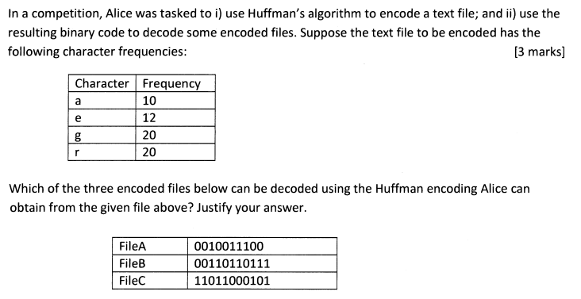
1. Create Huffman Codes using the Given Frequencies
First, we'll use Huffman's algorithm to generate the binary codes for each character based on their frequency.
The character frequencies provided are:
- a: 10
- e: 12
- g: 20
- r: 20

Step-by-Step Huffman Encoding Process:
- List the frequencies: We have characters with frequencies: a (10), e (12), g (20), and r (20).
- Build a min-heap: Start by treating each character as a leaf node, and the frequency is the priority for building the heap.
  - Heap: [a (10), e (12), g (20), r (20)]
- Combine the two smallest frequencies: Combine a (10) and e (12) to form a new node with a frequency of 22.
  - Heap: [g (20), r (20), (a+e) (22)]
- Repeat the process: Combine g (20) and r (20) to form a new node with a frequency of 40.
  - Heap: [(a+e) (22), (g+r) (40)]
- Combine the final two nodes: Combine (a+e) (22) and (g+r) (40) to form the root node with a total frequency of 62.
  - Final tree: The root node has a frequency of 62.

Huffman Tree:
- At the root, we split between (a+e) and (g+r).
- For the (a+e) subtree, a will be assigned one bit and e the other.
- For the (g+r) subtree, g and r will similarly be assigned different bits.

Resulting Huffman Codes:
- a: 00
- e: 01
- g: 10
- r: 11

2. Determine Which Files Can Be Decoded Using These Codes
File A: 0010011100
- Split the code using the Huffman codes:
  - 00 → a
  - 10 → g
  - 01 → e
  - 11 → r
  - 00 → a
- Decoded sequence: a, g, e, r, a.
- File A can be decoded successfully as "agera".

File B: 00110110111
- Split the code using the Huffman codes:
  - 00 → a
  - 11 → r
  - 01 → e
  - 10 → g
  - 11 → r
- Decoded sequence: a, r, e, g, r.
- File B can be decoded successfully as "aregr".

File C: 11011000101
- Split the code using the Huffman codes:
  - 11 → r
  - 01 → e
  - 10 → g
  - 00 → a
  - 10 → g
  - 1... → Unfinished bit sequence at the end.
- The last 1 cannot be decoded because there’s no valid code for a single 1. Therefore, File C cannot be fully decoded.

Conclusion:
- File A and File B can be successfully decoded using Alice's Huffman encoding.
- File C cannot be fully decoded because it ends with an incomplete or invalid bit sequence.

4. Algorithm A and Algorithm B have been designed to solve the same problem. The time complexity for Algorithm A is T(n)= 200n and for Algorithm B is T(n)=2n2.
a. Which algorithm would be more efficient, eventually? Use the value of n to show when this algorithm can begin to demonstrate that it has better algorithmic efficiency.
b. To run the algorithm you identified in point a (above) on a computer that can perform 104 basic operations in one second, what would be the largest problem size that can be solve in two minutes?
(a) Comparison of Algorithms A and B's Efficiency
We are given two time complexity functions:
- Algorithm A: TA(n)=200nT_A(n) = 200nTA​(n)=200n
- Algorithm B: TB(n)=2n2T_B(n) = 2n^2TB​(n)=2n2
To determine which algorithm is more efficient eventually, we need to compare the time complexity functions for large values of nnn.
We compare the two functions TA(n)=200nT_A(n) = 200nTA​(n)=200n and TB(n)=2n2T_B(n) = 2n^2TB​(n)=2n2:
- When nnn is small, TA(n)T_A(n)TA​(n) will be larger than TB(n)T_B(n)TB​(n), but as nnn grows, TB(n)T_B(n)TB​(n)'s quadratic growth will eventually dominate TA(n)T_A(n)TA​(n)'s linear growth.
To find the crossover point (when Algorithm A becomes more efficient than Algorithm B), set the two time complexities equal to each other:
200n=2n2200n = 2n^2200n=2n2
Solving this equation:
n2=100nn^2 = 100nn2=100n n(n−100)=0n(n - 100) = 0n(n−100)=0
Thus, n=100n = 100n=100 is the crossover point. For n>100n > 100n>100, Algorithm A (with linear time complexity) will be more efficient than Algorithm B (with quadratic time complexity).
Conclusion for (a):
- Algorithm A becomes more efficient than Algorithm B when n>100n > 100n>100.
(b) Largest Problem Size Solvable in Two Minutes
We know the computer can perform 10410^4104 basic operations per second, and we want to solve the problem in two minutes (i.e., 120120120 seconds).
Thus, the total number of operations that can be performed in two minutes is:
104×120=1,200,000 operations10^4 \times 120 = 1,200,000 \, \text{operations}104×120=1,200,000operations
Now, using Algorithm A's time complexity TA(n)=200nT_A(n) = 200nTA​(n)=200n, we can determine the largest nnn that can be solved within 1,200,0001,200,0001,200,000 operations:
200n≤1,200,000200n \leq 1,200,000200n≤1,200,000
Solving for nnn:
n≤1,200,000200=6,000n \leq \frac{1,200,000}{200} = 6,000n≤2001,200,000​=6,000
Conclusion for (b):
- The largest problem size nnn that can be solved in two minutes using Algorithm A is 6,000\boxed{6,000}6,000​.

2018 – sem 2
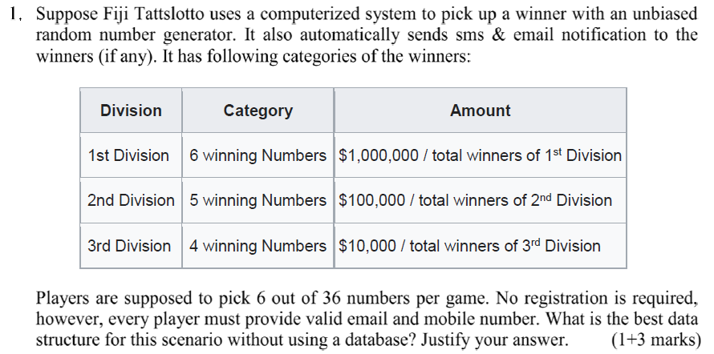
1. Why a Hash Table?
A hash table provides an efficient way to store and retrieve player data, particularly the email and mobile number of the winners, in constant average time O(1)O(1)O(1). In this scenario, every player’s email and mobile number must be stored, and once the system determines the winners, it needs to look up and send notifications efficiently.
2. Justification:
- Fast Insertion and Lookup:
  - Each player's email and mobile number can be stored in a hash table as key-value pairs. The key can be a combination of the player's unique identifiers (like their name or mobile number) or simply their mobile number. The value can be additional data such as the player's email or whether they are a winner. Since a hash table provides average-case O(1)O(1)O(1) time complexity for both insertions and lookups, it allows efficient storage and fast access to player information when notifying winners.
- Memory Efficiency:
  - A hash table is a memory-efficient solution because it only stores player data once, and only for those who have provided valid mobile numbers and emails. There is no need for complex structures like trees or linked lists to handle this, keeping memory usage minimal.
- Unbiased Random Selection:
  - The system needs to randomly pick winners based on the numbers they selected. This can be done efficiently by scanning through the hash table and identifying the winners who meet the specific division criteria (1st Division, 2nd Division, etc.). Once the winners are identified, retrieving their contact details (email and phone number) from the hash table happens in constant time.
- No Need for a Database:
  - Since no database is used, a hash table acts as a simple in-memory solution that doesn’t require complex storage mechanisms. It suits the scenario where the data doesn't need to persist beyond the game's duration, and players aren’t required to register beforehand.
3. How it Fits the Scenario:
- No Registration Required: The hash table dynamically stores player information as the game progresses, and it only requires a valid mobile number and email for each player.
- Efficient Winner Notification: Once the winners are determined, their details (email and mobile number) can be retrieved from the hash table and used to send notifications instantly.
- Divisions and Prizes: The prize distribution per division can be stored and tracked separately, while the hash table simply helps retrieve winner data and ensure fast notifications.
Conclusion:
A hash table is the ideal data structure for this lottery system because of its constant time complexity for insertions and lookups, its efficiency in handling a large number of players, and its ability to quickly notify winners based on the lottery's random number selection process.
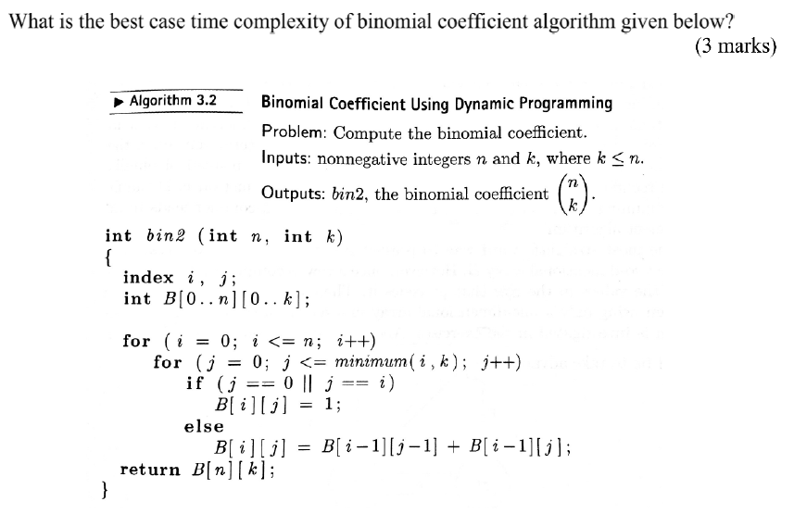
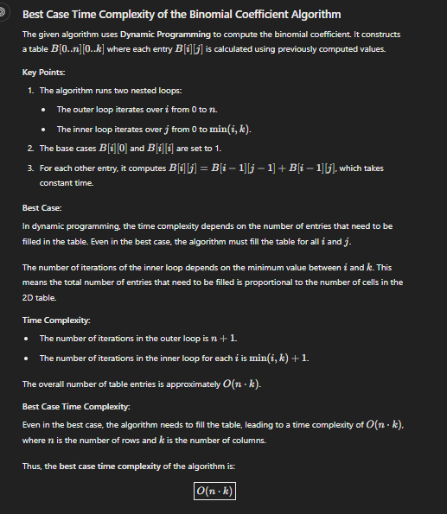

The floyd's algorithm given below in Figures 1 (a) has generated the path table in Figure 1 (c) from the given graph in Figure 1 (b) to determine the shortest path. What is the shortest path from node 4 to node 2? Show your working.
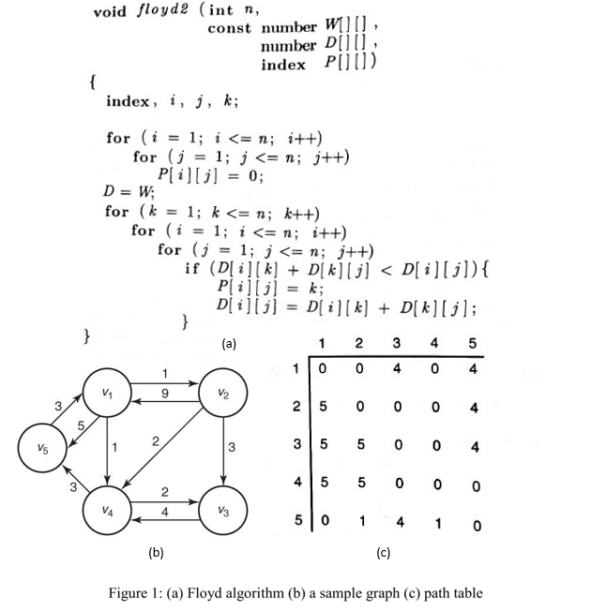

Shortest Path from Node 4 to Node 2
Given the path table in Figure 1 (c) from the Floyd's Algorithm, we need to determine the shortest path from node 4 to node 2.
Step-by-Step Process:
- Path Table Analysis:
  - The entry at row 4, column 2 in the path table is 1. This indicates that the shortest path from node 4 to node 2 goes through node 1.
- Path Construction:
  - Start at node 4.
  - Move to node 1 as indicated by the path table.
  - From node 1, move to node 2 directly.
- Detailed Steps:
  - Node 4 to Node 1: According to the graph, the weight from node 4 to node 1 is 3.
  - Node 1 to Node 2: The weight from node 1 to node 2 is 1.
- Total Weight Calculation:
  - Total weight = Weight from node 4 to node 1 + Weight from node 1 to node 2
  - Total weight = 3 + 1 = 4
Conclusion:
- The shortest path from node 4 to node 2 is: Node 4 -> Node 1 -> Node 2
- The total weight of this path is: 4.

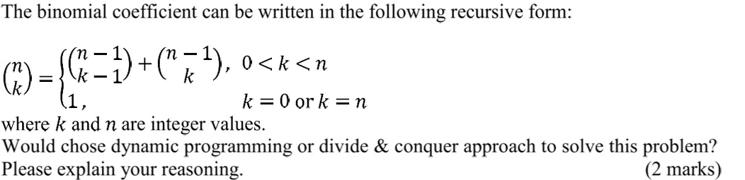
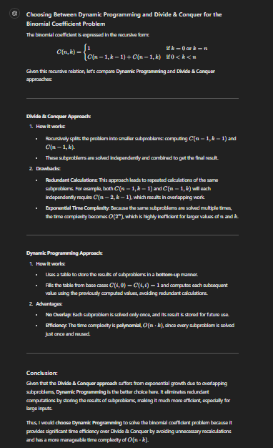

1. Design Test Cases:
- Best-case input: Create input data that is structured in a way that the algorithm performs the fewest operations (e.g., for sorting algorithms, this could be an already sorted array).
- Worst-case input: Design input that forces the algorithm to perform the most operations (e.g., a reverse-sorted array for a sorting algorithm).
- Average-case input: Generate input data that represents a typical or random case.
- Varying input sizes: Run the algorithms on different sizes of input to observe how they scale.
2. Measure Execution Time:
- Use a timer (e.g., System.nanoTime() in Java, or time.time() in Python) to measure the time taken for the algorithm to run on different inputs.
- Run the algorithms multiple times on each input to account for variability in system performance, and take the average execution time.
- For each input size, record the times for best-case, average-case, and worst-case inputs.
3. Approximate Time Complexities:
- Best-case B(n)B(n)B(n): Use the test case where the algorithm performs the least number of operations and record the time taken. This gives an approximation of the best-case time complexity.
- Worst-case W(n)W(n)W(n): Similarly, use the test case where the algorithm performs the most operations to approximate the worst-case time complexity.
- Average-case A(n)A(n)A(n): Run the algorithm on random inputs or average input scenarios multiple times. The average execution time across different random inputs gives the average-case complexity.
- Every-case T(n)T(n)T(n): Plot the execution time as a function of input size. The function T(n)T(n)T(n) is the empirical time complexity curve derived from the data.
4. Analyze the Results:
- Plot graphs of the time taken versus input size for each algorithm and each case (best, average, worst).
- Compare the growth rate of the time for each case (e.g., linear, quadratic, logarithmic, etc.).
- Fit a curve: Use regression or curve-fitting techniques to approximate the function T(n)T(n)T(n), B(n)B(n)B(n), A(n)A(n)A(n), and W(n)W(n)W(n). This will allow the student to express the time complexities in Big-O notation.
Example:
Let’s say the student is comparing two sorting algorithms:
- Best-case input: Sorted array.
- Worst-case input: Reverse-sorted array.
- Average-case input: Randomly generated array.
By running both algorithms on these inputs for different input sizes nnn, measuring the time taken, and plotting the results, the student can approximate the time complexity for each case and compare the two algorithms' efficiency.
Conclusion:
To approximate T(n),B(n),A(n),W(n)T(n), B(n), A(n), W(n)T(n),B(n),A(n),W(n), the student must design appropriate test cases, measure execution time empirically, and then analyze the results by plotting time versus input size and determining the time complexity behavior for each case.

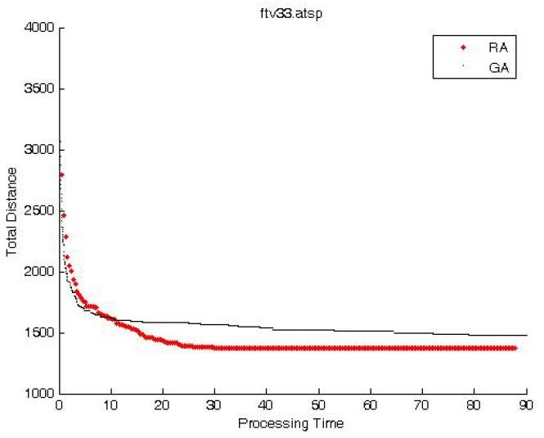

The Genetic Algorithm (GA) is clearly more efficient compared to the Random Algorithm (RA). The GA achieves a consistently lower total distance as the processing time increases. This suggests that GA converges to a more optimal solution faster and maintains this efficiency over time. In contrast, the RA shows greater variability and higher total distances, indicating less reliable performance.
Thus, the GA is more efficient in solving the travelling salesman problem due to its ability to find and maintain more optimal solutions over time.

2019 – sem 2

1. Define the Input Range:
- Let the parameter, nnn, represent a non-negative integer.
- The student should define a suitable range of nnn values (e.g., from 1 to a sufficiently large number), ensuring the range is broad enough to observe performance differences.
2. Measure Execution Time:
- For each value of nnn, measure the execution time of both functions.
- This can be done using built-in timing functions in the programming language, such as System.nanoTime() in Java or time.time() in Python.
- Collect execution time for each function over multiple runs to minimize noise (e.g., averaging the results of 5–10 runs for each nnn).
3. Plot the Results:
- Plot the measured execution times against nnn on a graph (with nnn on the x-axis and time on the y-axis).
- This helps visualize how the execution time grows as nnn increases.
4. Analyze the Growth Patterns:
- Observe the trend of the execution times. Common growth patterns include:
  - Constant (O(1)): The execution time remains constant regardless of nnn.
  - Linear (O(n)): The execution time grows proportionally with nnn.
  - Quadratic (O(n^2)): The execution time grows proportionally with the square of nnn.
  - Logarithmic (O(log n)): The execution time grows logarithmically as nnn increases.
  - Exponential (O(2^n)): The execution time doubles with each increase in nnn.
- The student should compare the observed growth rates for the two functions.
5. Fit the Time Complexity Model:
- Using the graph, fit the data to standard complexity classes (e.g., O(1), O(n), O(n^2)) by comparing the shape of the curve.
- Alternatively, the student can calculate the ratios of execution times for successive nnn values to approximate the complexity. For example:
  - If the ratio stays constant, it may suggest O(n).
  - If the ratio grows, it could indicate O(n^2) or higher.
  - If the ratio decreases, it could suggest O(log n).
6. Confirm Results with Larger nnn:
- Test larger values of nnn to verify the time complexity approximation.
- Sometimes smaller values of nnn can be deceptive, especially if the constant factors dominate performance.
Conclusion:
The student can approximate the every-case time complexity by empirically measuring execution time for varying input sizes, plotting the results, and identifying the trend that matches known complexity patterns.
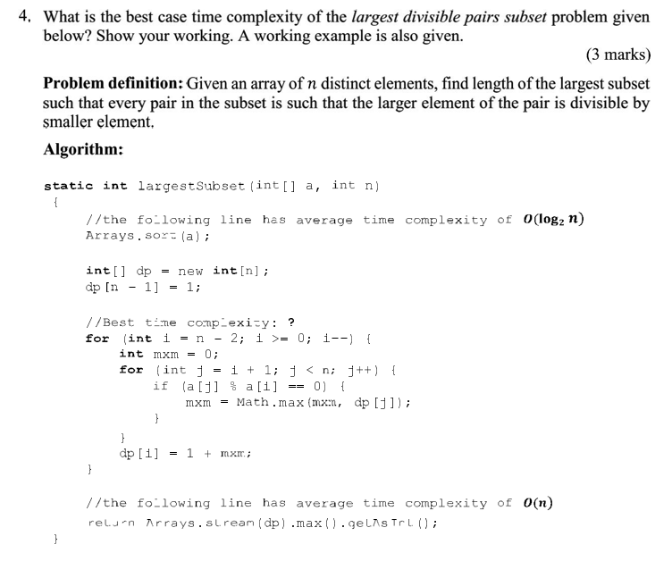
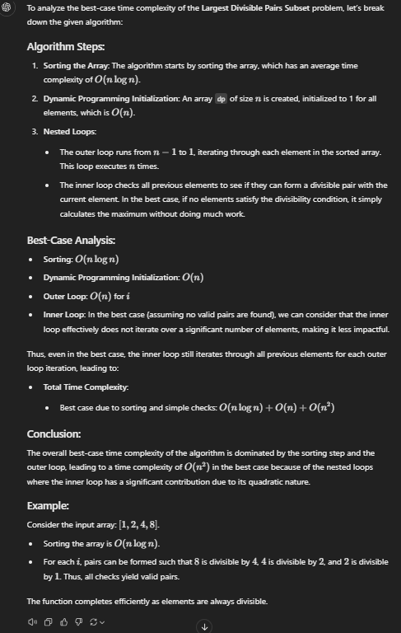

Given that deterministic approaches like dynamic programming, divide and conquer, and greedy algorithms result in no better than O(2n)O(2^n)O(2n) average-case time complexity for preparing a satisfactory USP timetable, this suggests the problem is computationally hard, likely NP-complete or NP-hard. Solving such problems exactly is infeasible for large inputs due to exponential time complexity. In this case, heuristic or metaheuristic approaches would be more practical.
How I Would Solve the Problem:
- Use Approximation or Heuristic Algorithms:
  - Genetic algorithms: This evolutionary approach simulates the process of natural selection. It uses a population of candidate solutions (timetables) and evolves them through selection, crossover, and mutation to find a near-optimal solution over several generations.
  - Simulated Annealing: This technique explores the solution space by accepting not only better solutions but also worse ones with a decreasing probability, allowing it to escape local optima and find a good, if not optimal, solution.
  - Tabu Search: This is a local search-based heuristic that keeps track of previously visited solutions (tabu list) to avoid cycling back and improve the exploration of the search space.
  - Constraint Satisfaction Heuristics: If the problem is framed as a constraint satisfaction problem (CSP), specific heuristics like backtracking with forward checking, constraint propagation, or using more intelligent variable ordering can help find good solutions.
- Would I Be Able to Produce the Optimum Timetable?
  - No, I cannot guarantee the optimum (best possible) timetable in a reasonable time frame, especially for large instances of the problem. Given the problem’s hardness, finding the true optimum in polynomial time is impractical.
  - However, using heuristic or metaheuristic methods, I can produce a near-optimal or satisfactory solution within a reasonable time frame, which often works well in real-world applications where "good enough" solutions are acceptable.
Conclusion:
To solve the USP timetable problem efficiently, I would use metaheuristic approaches such as genetic algorithms, simulated annealing, or tabu search. While these methods may not guarantee the optimum solution, they can deliver high-quality, near-optimal solutions within a reasonable time, making them suitable for such computationally complex problems.

2020 – sem 2
Using the appropriate data structure in a given algorithm is crucial for efficiency and performance. Different data structures offer various strengths and weaknesses, making them suitable for particular tasks while unsuitable for others. Choosing the right data structure can significantly impact the speed, memory usage, and overall complexity of an algorithm.
Examples:
- Arrays vs. Linked Lists:
  - Array: An array allows for quick access to elements via their index, making it excellent for scenarios where random access is needed. However, inserting or deleting elements can be costly, as it might require shifting multiple elements.
  - Linked List: A linked list is ideal for scenarios where frequent insertions and deletions are needed, as these operations can be performed in constant time. However, accessing elements is slower because it requires traversing the list from the beginning.
Is There a One-Size-Fits-All Data Structure?
There isn't a one-size-fits-all data structure because different applications have different requirements. Each data structure is designed to optimize certain operations at the expense of others. For instance, while arrays are great for random access, linked lists excel at insertions and deletions. Similarly, hash maps provide quick access but lack order, whereas tree maps maintain order but with slightly slower operations.
2. Determine the worst case time complexity of the Travelling Salesman Problem using the brute force approach? Show your working.
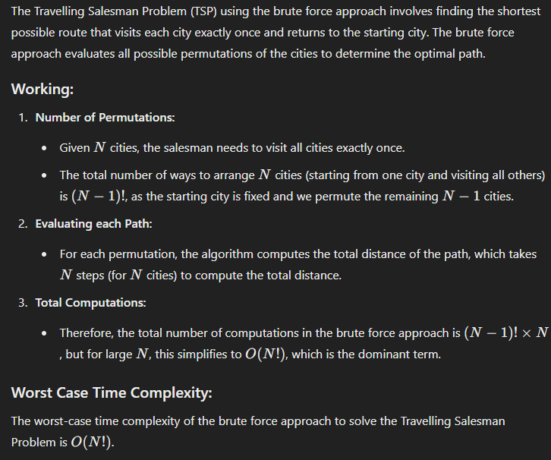
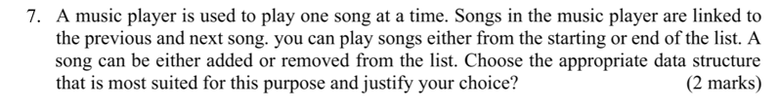
A music player is used to play one song at a time. Songs in the music player are linked to the previous and next song. you can play songs either from the starting or end of the list. A song can be either added or removed from the list. Choose the appropriate data structure that is most suited for this purpose and justify your choice? (2 marks)
For this scenario, a Doubly Linked List is the most appropriate data structure for a music player. Here’s why:
Justification:
- Bidirectional Navigation:
  - A doubly linked list allows traversal in both directions (forward and backward). This is ideal for a music player where you need to navigate to the previous or next song seamlessly.
- Efficient Insertions and Deletions:
  - Adding or removing songs from the list can be done efficiently with a doubly linked list, as it requires updating only a few pointers. This avoids the overhead associated with shifting elements in an array.
- Flexibility:
  - A doubly linked list provides flexibility in playing songs from the start or end of the list, making it easy to implement features like shuffle or repeat.
Conclusion:
Using a doubly linked list ensures that your music player operates efficiently, with quick access and modification capabilities, making for a smooth user experience.

2022 – sem 2
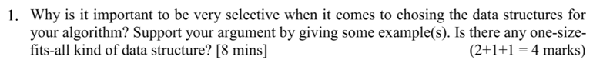
Being selective when choosing data structures for your algorithm is crucial because the efficiency of operations like insertion, deletion, access, and search directly depends on the properties of the data structure. The right choice can significantly improve an algorithm’s performance, while the wrong one can lead to inefficiencies that cause bottlenecks in execution, especially for large datasets.
For example, consider searching for an element in a list. If you choose an ArrayList (with O(n) search time) instead of a HashSet (with O(1) average search time), it could slow down your algorithm drastically if the list is large. Similarly, using a LinkedList for frequent random access is inefficient because it takes O(n) time to access elements by index, whereas ArrayList offers O(1) access time.
There's no one-size-fits-all data structure. Each has its strengths and weaknesses depending on the type of operation you prioritize. For instance, ArrayList is great for random access and sequential storage, while HashMap provides fast key-value lookups, and LinkedList excels at quick insertions and deletions. Selecting the right data structure involves understanding the operations your algorithm will rely on most and optimizing for those.

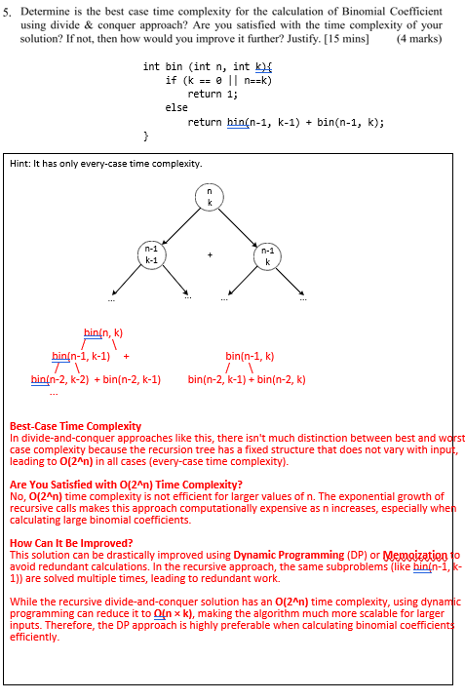

6. What kind of algorithmic design paradigm you will choose for the following large problems that can be practically implemented. Please justify your answer: [5 mins]
Traveling salesman problem
The traveling salesman problem (TSP) is a problem in graph theory requiring the most efficient (i.e., least total distance) path a salesman can take through each of the cities. TSP in an NP-hard problem.
NQueen Problem
The n-queens problem is about finding how many different ways queens can be placed on a chessboard so that none attack each other. The n-Queen problem becomes intractable for large 'n' values and is thus placed in NP (Non-Deterministic Polynomial) class problem.?
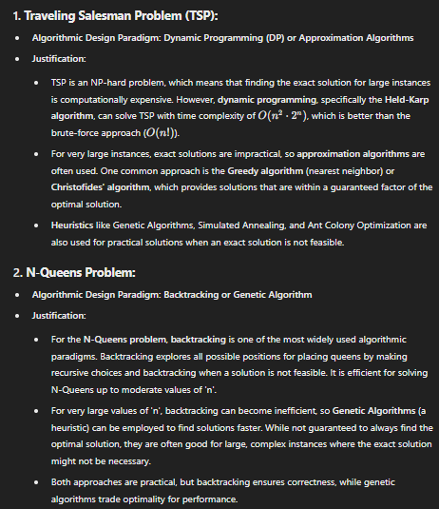
2023 – sem 2
When efficiency is the main concern, I generally prefer using ArrayList over LinkedList in most cases. ArrayList provides O(1) random access, making it ideal for algorithms that frequently access elements by index, and its contiguous memory structure offers better cache locality and lower memory overhead. Additionally, appending to the end of an ArrayList is efficient with amortized O(1) time. On the other hand, LinkedList is more suitable when frequent insertions or deletions occur in the middle of the list, as these operations are O(1). However, ArrayList is usually more efficient for typical use cases.
To empirically determine the Big O time complexity of an algorithm, you can test it with various input sizes and measure its runtime. Start by selecting a range of input sizes (e.g., 100, 200, 400) and run the algorithm multiple times for each size to calculate the average runtime. Use a high-precision timer to record execution time, then plot the input size against the runtime. Analyze how the runtime grows as the input size increases, comparing it to known complexity patterns like O(N), O(N^2), or O(log N). This helps you identify the algorithm's time complexity based on observed trends.

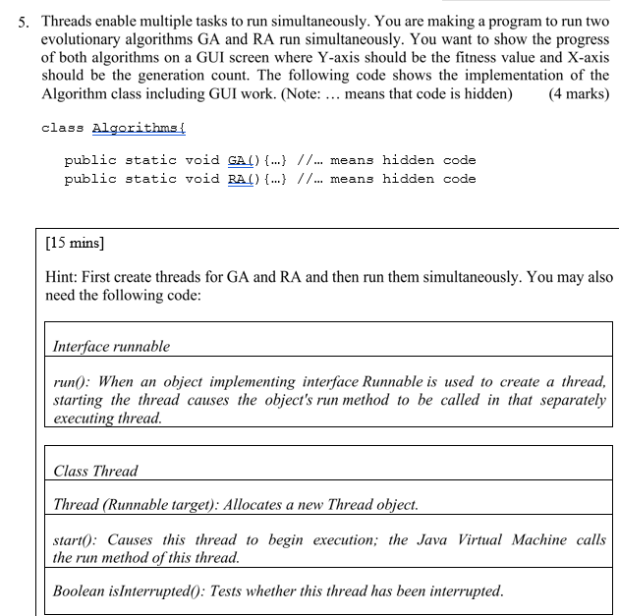
class GATask implements Runnable {
@Override
public void run() {
// Run the GA algorithm
Algorithms.GA();
}
}

class RATask implements Runnable {
@Override
public void run() {
// Run the RA algorithm
Algorithms.RA();
}
}
public class AlgorithmRunner {
public static void main(String[] args) {
// Create the GA and RA tasks
Runnable gaTask = new GATask();
Runnable raTask = new RATask();

// Create threads for both tasks
Thread gaThread = new Thread(gaTask);
Thread raThread = new Thread(raTask);

// Start both threads
gaThread.start();
raThread.start();

// Optional: Wait for both threads to finish (if necessary)
try {
gaThread.join();
raThread.join();
} catch (InterruptedException e) {
e.printStackTrace();
}
}
}
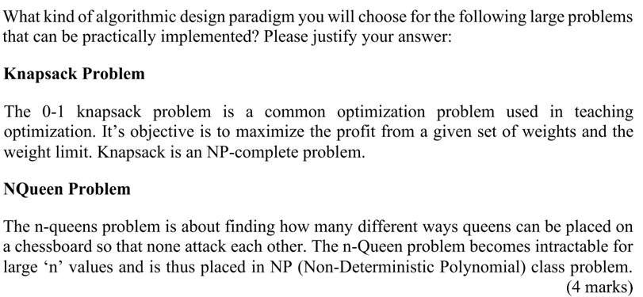

Knapsack Problem:
For the 0-1 Knapsack problem, the best algorithmic design paradigm to use is Dynamic Programming (DP). DP is well-suited for this problem because it breaks the problem down into smaller subproblems and uses the results of these subproblems to build up the final solution. Specifically, the problem can be solved by constructing a 2D table where one dimension represents the items and the other represents weight capacity. This ensures that we explore all possible item-weight combinations, providing an optimal solution. While the time complexity is O(nW)O(nW)O(nW) (where nnn is the number of items and WWW is the capacity), it's still practical for many real-world applications despite being NP-complete.
N-Queens Problem:
For the N-Queens problem, Backtracking is an ideal paradigm. The problem involves placing queens on the board one by one and checking constraints (no queens attacking each other). Backtracking systematically explores all possible placements of queens but prunes solutions when constraints are violated, making it more efficient than brute force. While it is exponential in time complexity, the pruning in backtracking makes it feasible for moderately large values of nnn. Other alternatives include genetic algorithms for approximate solutions when the problem size becomes too large for backtracking

